Caswell County Blueberry Pruning Workshop

North Carolina Cooperative Extension Caswell County Center is partnering with Legacy Acres blueberry farm to deliver an educational blueberry pruning workshop. This workshop will cover all aspects of dormant pruning of blueberry bushes and other similar woody plants. The workshop will include a “hands-on” portion where participants will be taught how to prune an established dormant bush. For demonstration purposes, participants will be given pruning loppers (seen in the second image below) that they can take home and keep after the workshop. Registration for the workshop is free.

To register for the workshop, please contact North Carolina Cooperative Extension Caswell County Center at 336-694-4158 by 12:00 noon on February 4th, 2019.

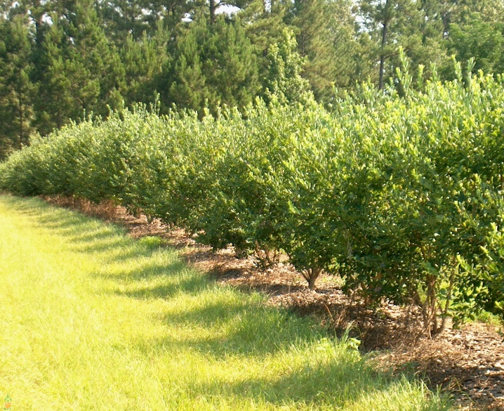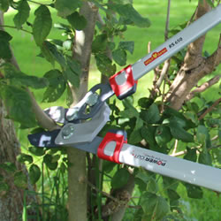

Event Details – Legacy Acres Farm, Pelham, NC

Date: Tuesday, February 6th, 2019

Time: 2:00 pm -‐ 5:00 pm

Location: Legacy Acres Farm

2185 Chandler Mill Road, Pelham, NC 27311

REGISTER TODAY

Call 336-694-4158
or email Nate Bruce at nsbruce@ncat.edu

Registration deadline is February 4th, 2019 by 12:00 noon.

